MidTerm Group 1/2/3 11-Mar-2025 17:30h
Name and ID :
Create folder YourID where you can put all pictures, notes, answers, SQL definitions and how you test that they are working (ER diagram, Table model, test sql, picture from output).

- [ x Points] Create ER Diagram and other requested tasks from picture Ex_1. You can use diagram.net or draw.io or on paper. At the end write 3 instances.

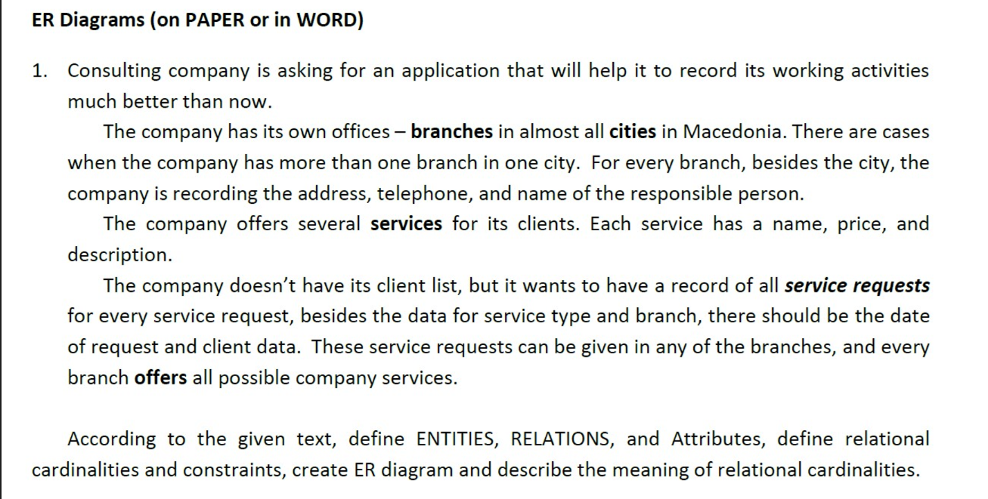

- [y points] Create Table Model and other requested tasks from picture Ex_2. You can use diagram.net or draw.io. In which order tables will be filled?
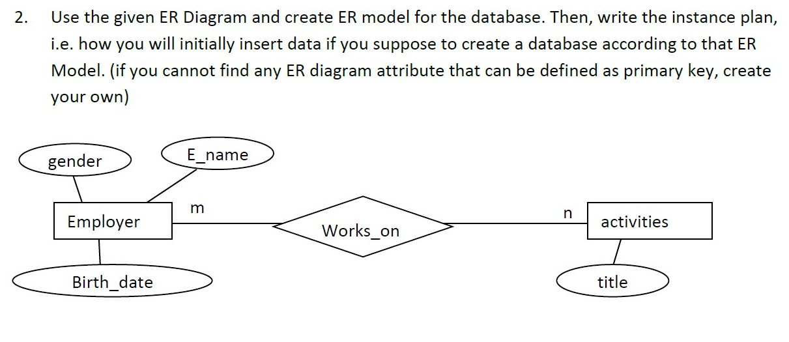
- [ z Points] Using relation algebra, operations for selection, projection, renaming write down relations to find below data from the table Switchboard:
  - Find all rows where argument is Suppliers
  - Find all data where Switchboard is 2 and output should show ItemText as Item, Command, Argument
  - Manually represent the output from the queries above
SwitchboardID | ItemNumber | ItemText | Command | Argument
1 | 0 | Main Switchboard | 0 | Default
1 | 1 | Forms | 1 | 2
1 | 2 | Reports | 1 | 3
1 | 3 | Exit Application | 6
2 | 0 | Forms Switchboard Page | 0
2 | 1 | Products | 3 | Products
2 | 2 | Suppliers | 3 | Suppliers
2 | 3 | Sales Representatives | 3 | Reps
2 | 4 | Product Lines | 3 | ProdLines
2 | 5 | Sales Reporting System | 2 | frmSRSmaster
2 | 6 | Return to Main Switchboard | 1 | 1
3 | 0 | Reports Switchboard Page | 0
3 | 1 | Total Sales by Rep | 4 | SalesbyRep
3 | 2 | Total Sales by Product | 4 | SalesbyProduct
3 | 3 | Total Sales by Product line | 4 | SalesbyProdLine
3 | 4 | Sales by Rep / Product | 4 | SalesbyRepProduct
3 | 5 | Rep Sales by Period | 3 | ReportDates
3 | 6 | Return to Main Switchboard | 1 | 1
- Using relation algebra, operations for selection, projection, renaming write down relations to find below data from the table Books:
  - Find all book from publisher Harper
  - Find all Books where retail_price is less than 10 and greater than 40 and to be shown Author, Title Publisher, Year of publishing, Price.
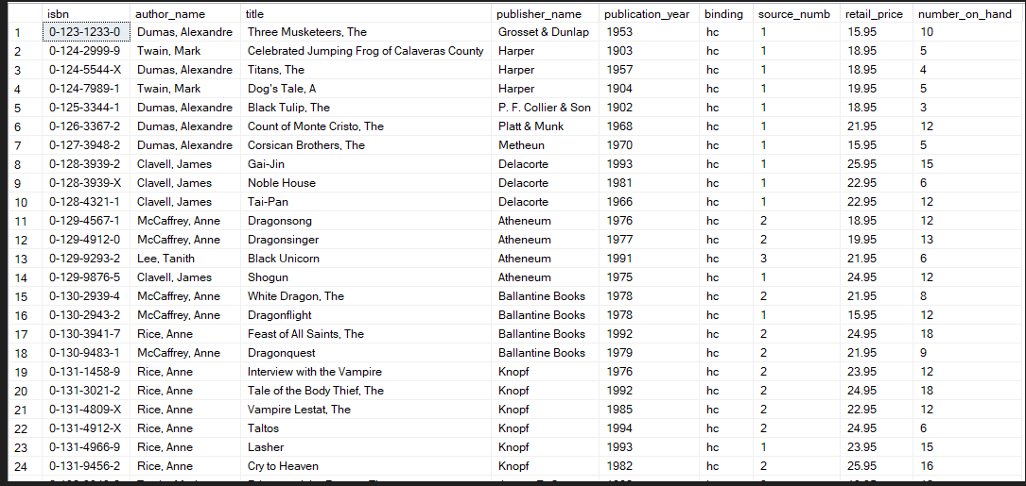

- Write the SQL query from 4.a and 4.b and write the output from the table above manually

Group 1/2: Create zip file from YourID folder and send it to zoran.gichevski@uacs.edu.mk
Group 3: Create zip file from YourID folder and send it to igor.janchev@uacs.edu.mk

